Table of Contents

1. Basic User Interface Design Diagram 1

2. Navigation Diagram 2

3. Json Data Structure Outline Example 2

4. State Transition Diagram 3

5. Class diagram 3

# 1. Basic User Interface Design Diagram

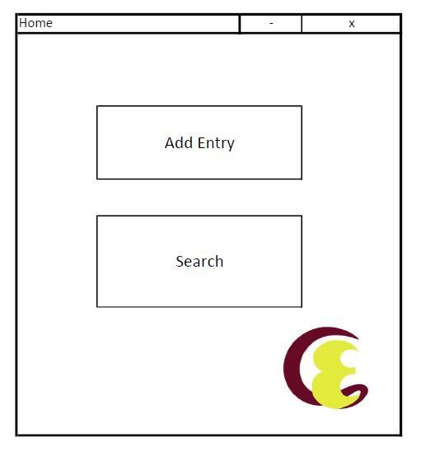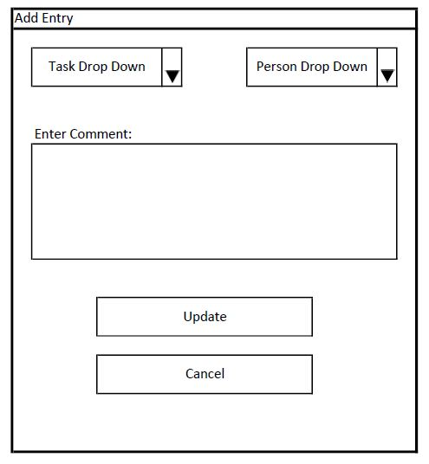

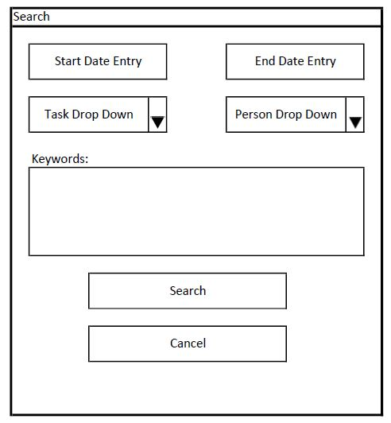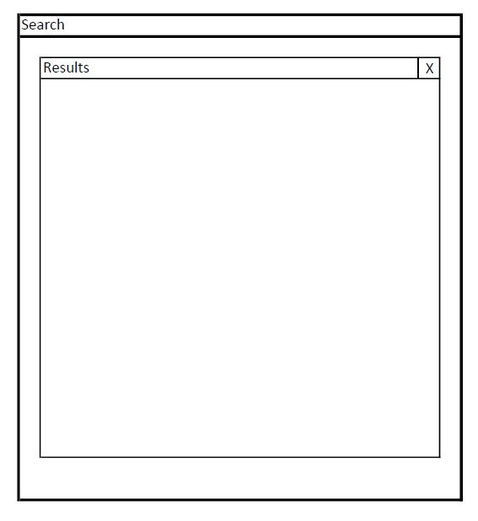

# 2. Navigation Diagram

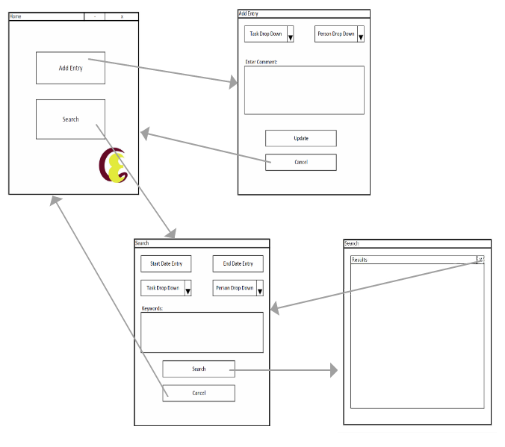

# 3. Json Data Structure Outline Example

{

“timestamp” : “2018-11-05T08:11:13:43.511-06:00”,

“task” : “Meeting”,

“person” : “TriNetra”,

“comment” : “Testing Application”

}

# 4. State Transition Diagram

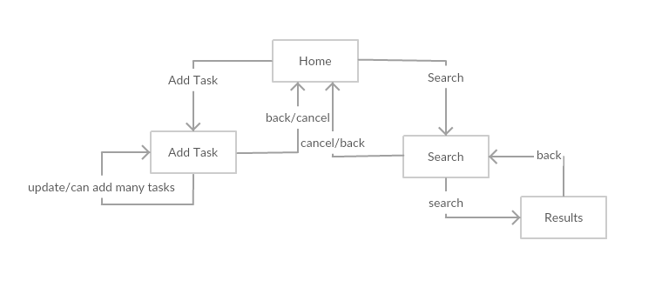

# 5. Class diagram

